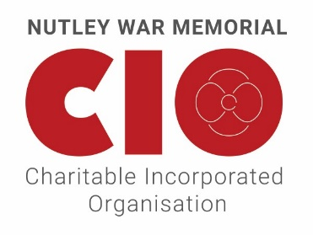
Voting Process and Members Responsibilities
Registered Charity No: 1189344

Notes on Membership
The CIO was registered with the Charity Commission on 4 May 2020. This formed part of an incorporation process to protect the trustees of the old charity (Nutley War Memorial Trust, Registered Charity No: 305277) from personal liability, and therefore ensure the viability of the charity in the future.
By a consultation process approved by the Charity Commission, the inhabitants of Nutley and surrounding area were invited to comment on the proposed incorporation. A Charity Commission Order dated 13 August 2020 authorised the transfer of the property from the old charity to the new CIO. Some of the charity’s property remains subject to a permanent endowment restriction in the terms of the original trusts.
Under the terms of the old charity, all of the inhabitants of the area who were over the age of 18 were entitled to vote at the Annual General Meeting (AGM). It is no longer possible with a CIO to have this form of membership because it is a statutory requirement that the CIO should have a members’ register. It would not be possible to do this if all inhabitants were automatically members. It would simply not be possible for the CIO to keep track of who currently resides in the area.
The arrangements for membership have therefore changed and a local resident who lives in Nutley or its vicinity, and who wishes to become a member of the CIO must apply for membership and be accepted by the trustees. [There is an online application form that can be found on the CIO’s website]. The trustees have the discretion to refuse membership if they feel that it is in the best interests of the CIO. There is an appeals process, but the decision of the trustees is final. Trustees also have the power to remove members, again if it is in the best interests of the CIO.
The trustees have the ability to ask for membership subscriptions if felt appropriate.
The members have no financial liability to the CIO if it were to wind up as a charity at any point in the future.
The members of a CIO do have a statutory duty to exercise their powers as a member of the CIO in a way in which they decide in good faith would be most likely to further the purposes of the CIO.
Only persons who are registered as members are entitled to vote at the AGM. [Non-members may attend but may not vote].

The Voting Process
This process will follow a period of consultation which results from the Nissen Richards Studio study, (details on the project website) and the presentation of options for members to vote on. There may also be a vote for new Trustees to the Nutley War Memorial CIO.
- Members will be sourced from the membership register.
- Each member will be allocated a unique number for the purpose of the vote.
- Ballot papers with the unique number but without the members name will be sent through the post to each member.
- The ballot will be managed by an independent body who will be supplied with a check list of numbers but not membership names.
- Members will complete the ballot papers and return them to the independent bodies return address by a specific date.
- Ballot papers supplied after the cut-off date will be noted but not counted.
- The Independent body will return the result to the Nutley War Memorial CIO who will post the result to members through the website.
- The Trustees will be bound by the decision of the membership.
Timescales and progress of the project can be found on the project website.

